How to play

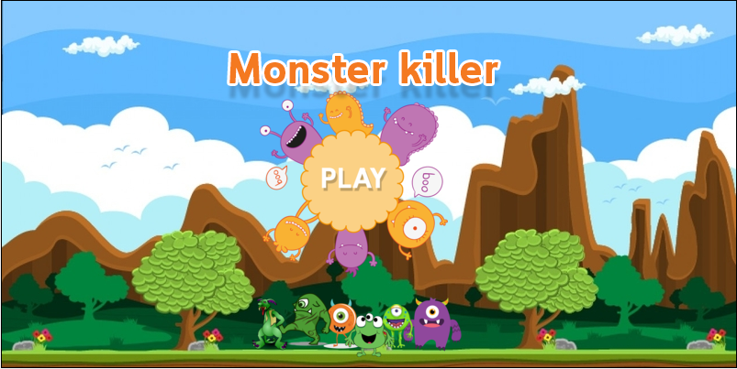

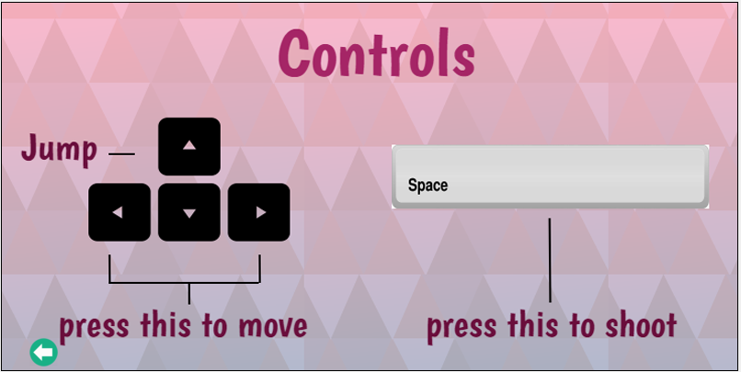

You have three level in this game

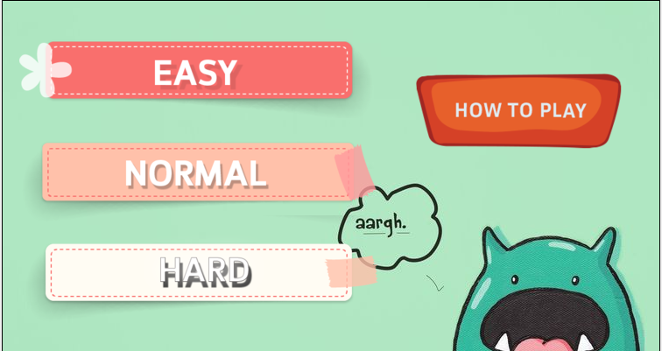

You have 200 of heart and you will collect the coins 50 coins in each level. If you collect 50 coins it mean you win in each game but if you run out of heart or you touch the boum it mean the game is over

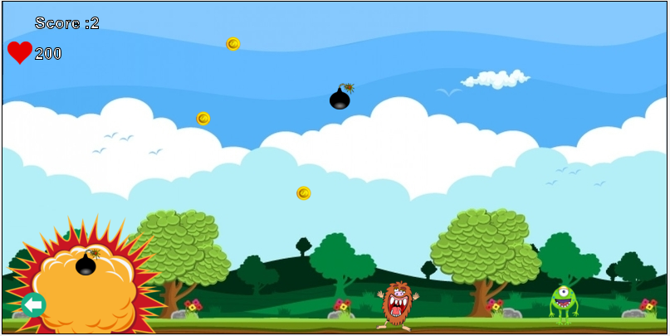

Level1 is the easy one

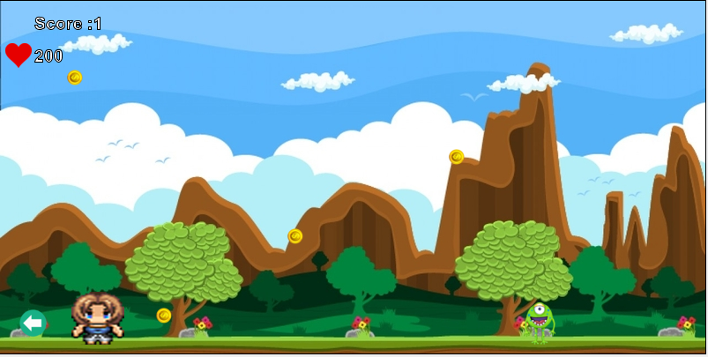

Level2 is more difficault it has a boum to be your troble

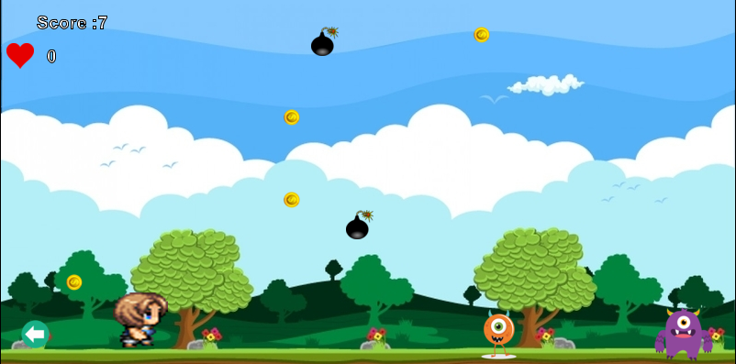

Level3 is the most difficualt level it more boum less coins and the monster is faster than level 1and2

